**Name :** Poojitha Talari

**Trainer Name :** Harshee Pitroda

**Course :** Basics of Python and ML

**Date :** 02-06-2022

**Q1**

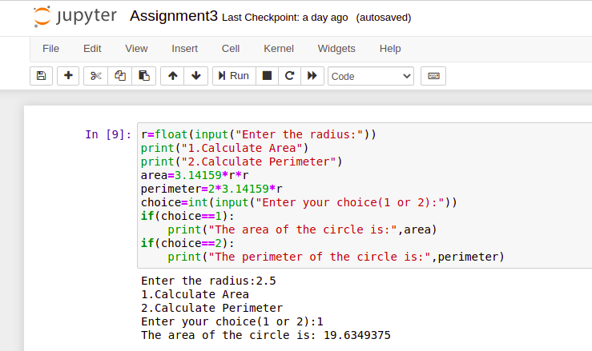

**Q2**

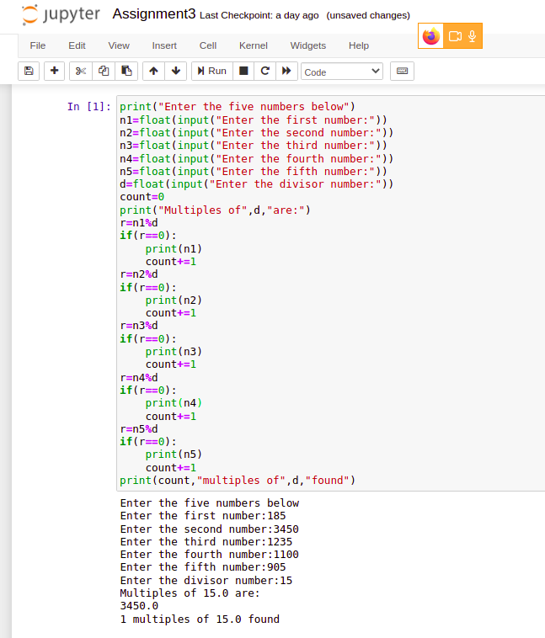

**Q3**

